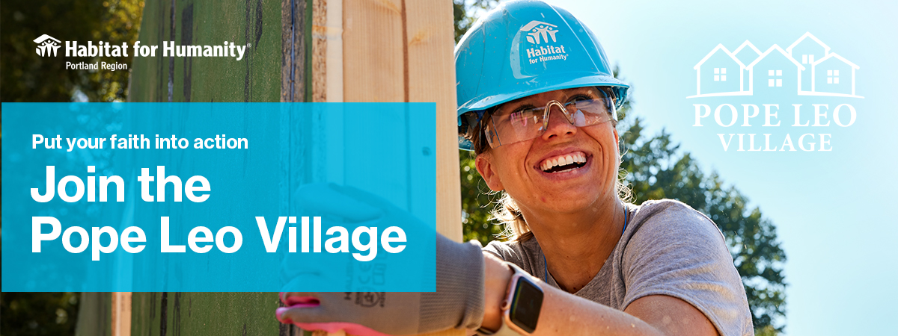

Building homes, community, and hope

[School/Faith Community] is proud to partner with Habitat for Humanity Portland Region
in support of the Pope Leo Village, a faith-inspired campaign to build 17 affordable Habitat homes
at Twenty Fifth Terrace in SW Portland.

3 ways to participate
Volunteer: Lend a hand at a construction site or ReStore. Help build a Habitat home to advance our
mission of affordable homeownership or volunteer at one of our ReStores, where all proceeds help us
build homes across the Portland Region.
Give: Donate directly to help fund 17 affordable homes at Twenty Fifth Terrace.
Fundraise: Create a fundraising page and mobilize your network.

Our [school/faith community] is supporting Pope Leo Villages by:

$X,XXX Fundraising Goal
To donate, scan the QR code below to visit our fundraising page:
[Insert your JustGiving fundraising link]
XXX-hr & XXX Person
Volunteering Goal

Insert QR Code

To get learn more, visit habitatportlandregion.org/popeleovillage
and contact [Coordinator name, coordinator job title] to get involved.
coordinator.email@email.com | 123-456-7890

The Pope Leo Village campaign runs through February 2027. All gifts are tax-deductible as allowed by law, and support Habitat for Humanity Portland Region’s Twenty Fifth Terrace community.

The Pope Leo Village brings together people of all faiths, identities, and generations to create affordable housing and lasting community. Every gift and every hour of service make a difference.
“In that service to others we may find that coming together in friendship,
building up community, we too can find true meaning in our lives.”
- Pope Leo XIV

